**Vision(RoboGuide) 메모**

1. ROBOGUIDE **New Cell** 생성 *Robot Option에서 **iRVision 2DV(j901)** 추가

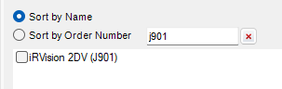

2 . Sensor Units - Add Vision Sensor Unit - Add 2D Camera - CAD Library

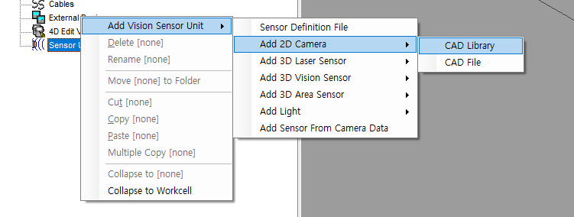

3. **Camera_BW** 선택

4. **Camera1** 세팅

- Setting - Focus Length = 8mm *실물 Vision확인

- View - Height = 600 *카메라 높이

5. Variables - Vision - Enable Vision Simulation

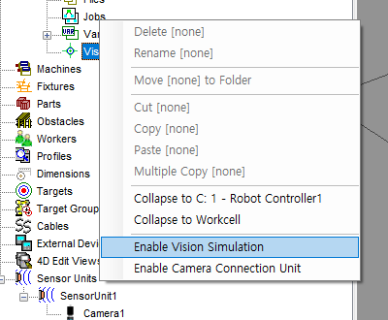

6 Variables - Vision 속성 - General - Device 설정

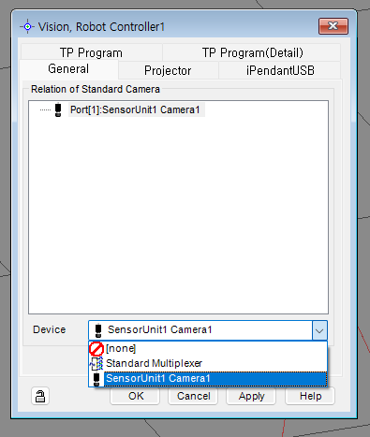

7. Robot - Internet Explorer

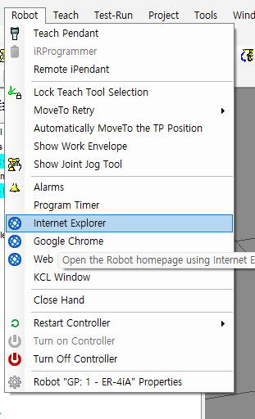

7. iRVision - IRVision Vision Setup

